**Tablet** layout (portrait):

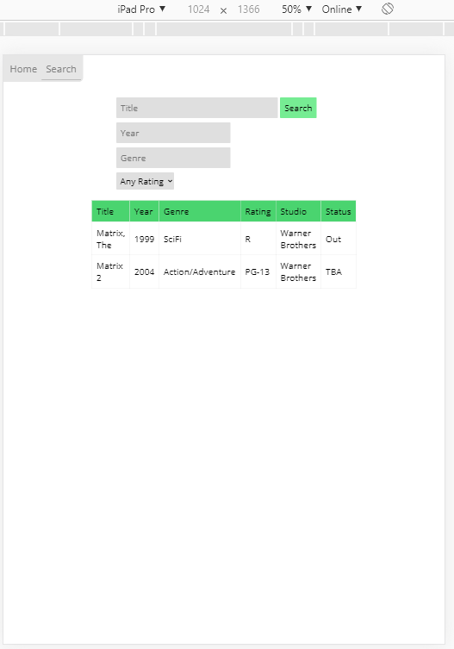

**Tablet** (landscape):

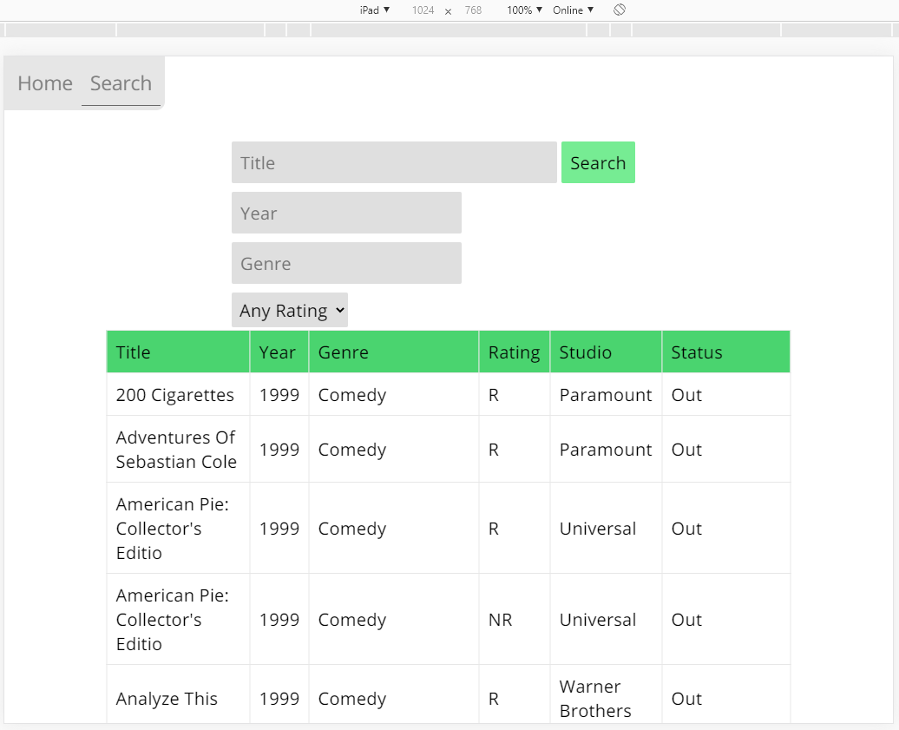

**Mobile** (portrait):

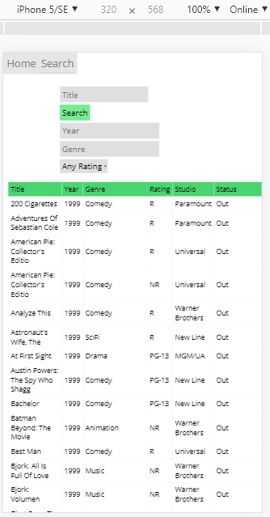

**Mobile** (landscape):

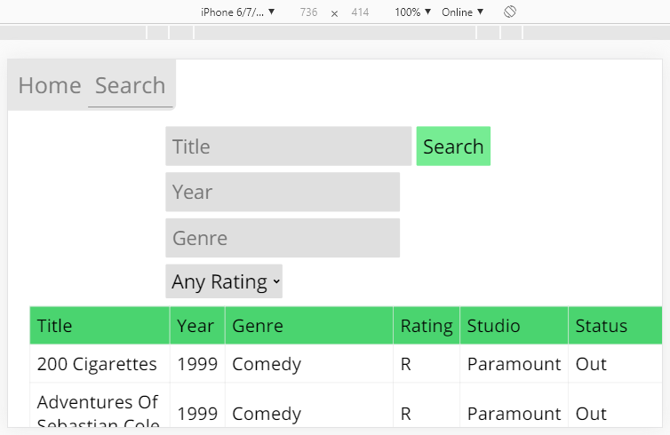

**Desktop**:

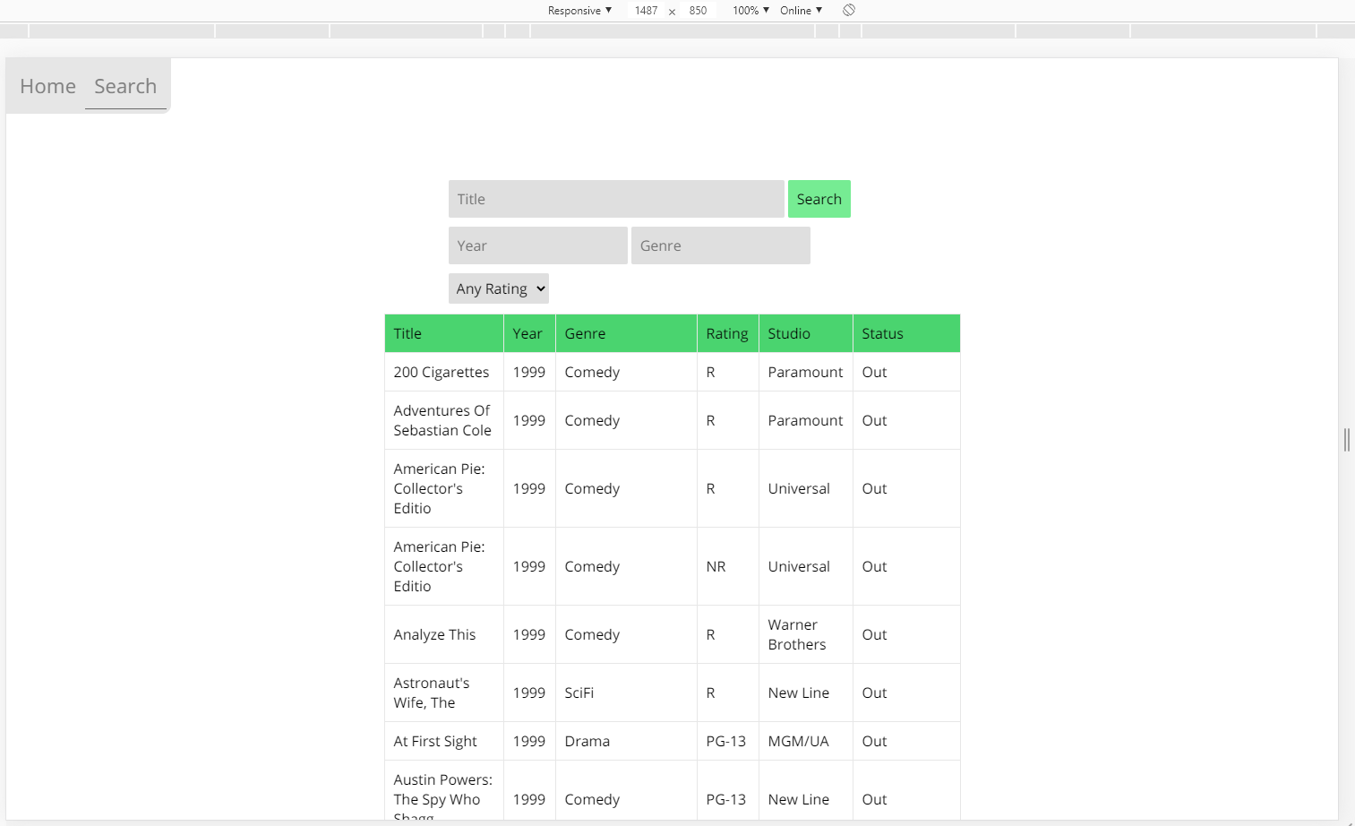

**Home Page** in different sizes

|  |  |
| --- | --- |
|  |  |
|  | |

|  |  |
| --- | --- |
| *Testing the bounds of the Search function…*  **No search filters/Title:** | Only 1 filter applied: **Year = 1** |
| **Genre = a** | **Title = ‘ OR 1 == 1**    The user could possibly find a vulnerability here, so I can insert an IF statement into the code to check that *$result is TRUE* (an error has occurred if mysqli_query() returns false) |
|  | |